

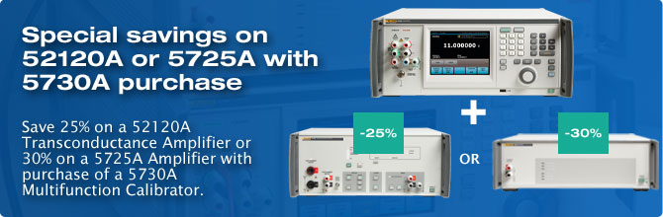

November 2nd, 2015

**Rep Alert - 5730A Bundle Choice Promotion - EUR**

Dear Sales Partner,

Please find below the details of an end of year customer promotion with the 5730A Multiproduct Calibrator bundled with a 5725A Amplifier or 52120A Transconductance Amplifier.

**Promotion:**

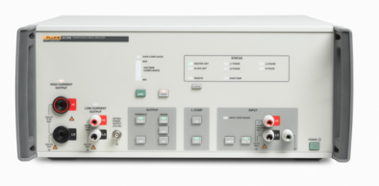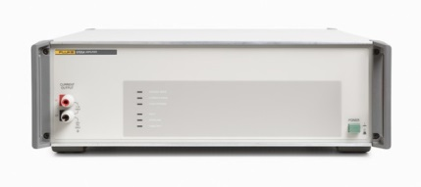Purchase a Fluke 5730A Multi-Product Calibrator (with or without any wide band option) at regular list price and add either the specially priced 5725A-PRO Amplifier OR Fluke 52120A-PRO Transconductance Amplifier to the same order and receive respectively 30% off the standard 5725A list price or 25% off the standard list price of a 52120A.

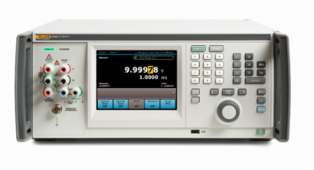

**5730A at list price PLUS 52120A (-25%) OR 5725A (-30%)**

**Promotion perod**: November 2nd – December 16th, 2015

**How this promotion works:**

Simply place your order for a 5730A, 5730A/03 or 5730A/05 and a 5725A-PRO or 52120A-PRO on one purchase order.

The 5725A-PRO and 52120A-PRO are standard products specifically priced for this promotional offering. These promotional models cannot be ordered separately and must be ordered with one 5730A, 5730A/03 or 5730A/05 on the same purchase order.

***The following 5730A models are qualifying purchases (at list price)***

|  |  |  |  |
| --- | --- | --- | --- |
| **Oracle #** | **Model#** | **Description** | **EUR** |
| 4334885 | 5730A 230 | Multifunction Calibrator | 57,220 |
| 4334897 | 5730A/03 230 | Multifunction Calibrator with 30 MHz Wideband AC Voltage Option | 67,630 |
| 4719075 | 5730A/05 230 | Multifunction Calibrator with 50 MHz Wideband AC Voltage Option | 69,185 |

***The following is a qualifying model whose price reflects a 25% discount from standard list.***

|  |  |  |  |
| --- | --- | --- | --- |
| **Oracle #** | **Model#** | **Description** | **EUR** |
| 4752824 | 52120A-PRO | Transconductance Amplifier - Promo sales only | 16,310 |

***The following is a qualifying model whose price reflects a 30% discount from standard list.***

|  |  |  |  |
| --- | --- | --- | --- |
| **Oracle #** | **Model#** | **Description** | **EUR** |
| 4752813 | 5725A-PRO 220 | Amplifier - Promo sales only | 15,045 |

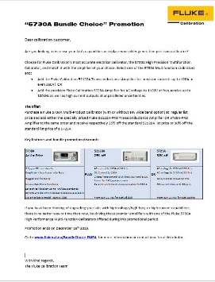

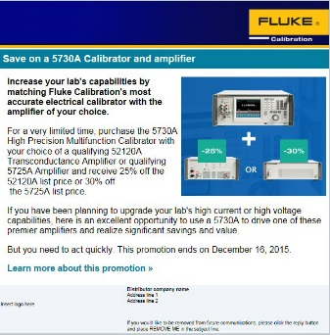

**How to promote:**

* Promotional banner and page on FCAL website  
  <http://eu.flukecal.com/BundleChoice-EMEA>
* Letter to key customers from Fluke Calibration  
  (Same list that received box promo with 5730A intro)
* Html mail to end customers

**Terms and conditions:**

* During the Promotion Period described get a 25% discount from current list price on a qualifying Fluke Calibration 52120A Transconductance Amplifier or a 30% discount from current list price on a qualifying 5725A Amplifier when you purchase one qualifying 5730A, 5730A/03 or 5730A/05 High Performance Multifunction Calibrator (on the same purchase order).
* Qualifying Models 5725A-PRO and 52120A-PRO are the same as standard models, except they have been priced to reflect the promotional discount and cannot be purchased separately.
* Only one 5725A-PRO or 52120A-PRO model may be purchased per 5730A ordered.
* Each qualifying purchase must be made during the promotion period.
* This offer may not be combined with any other offer, trade-in or used equipment purchase.
* No credit will be given for previous purchases for this equipment combination on orders placed prior to the start date of this promotion November 2nd, 2015.
* This offer is void where prohibited by law.

EMEA Fluke Calibration Team